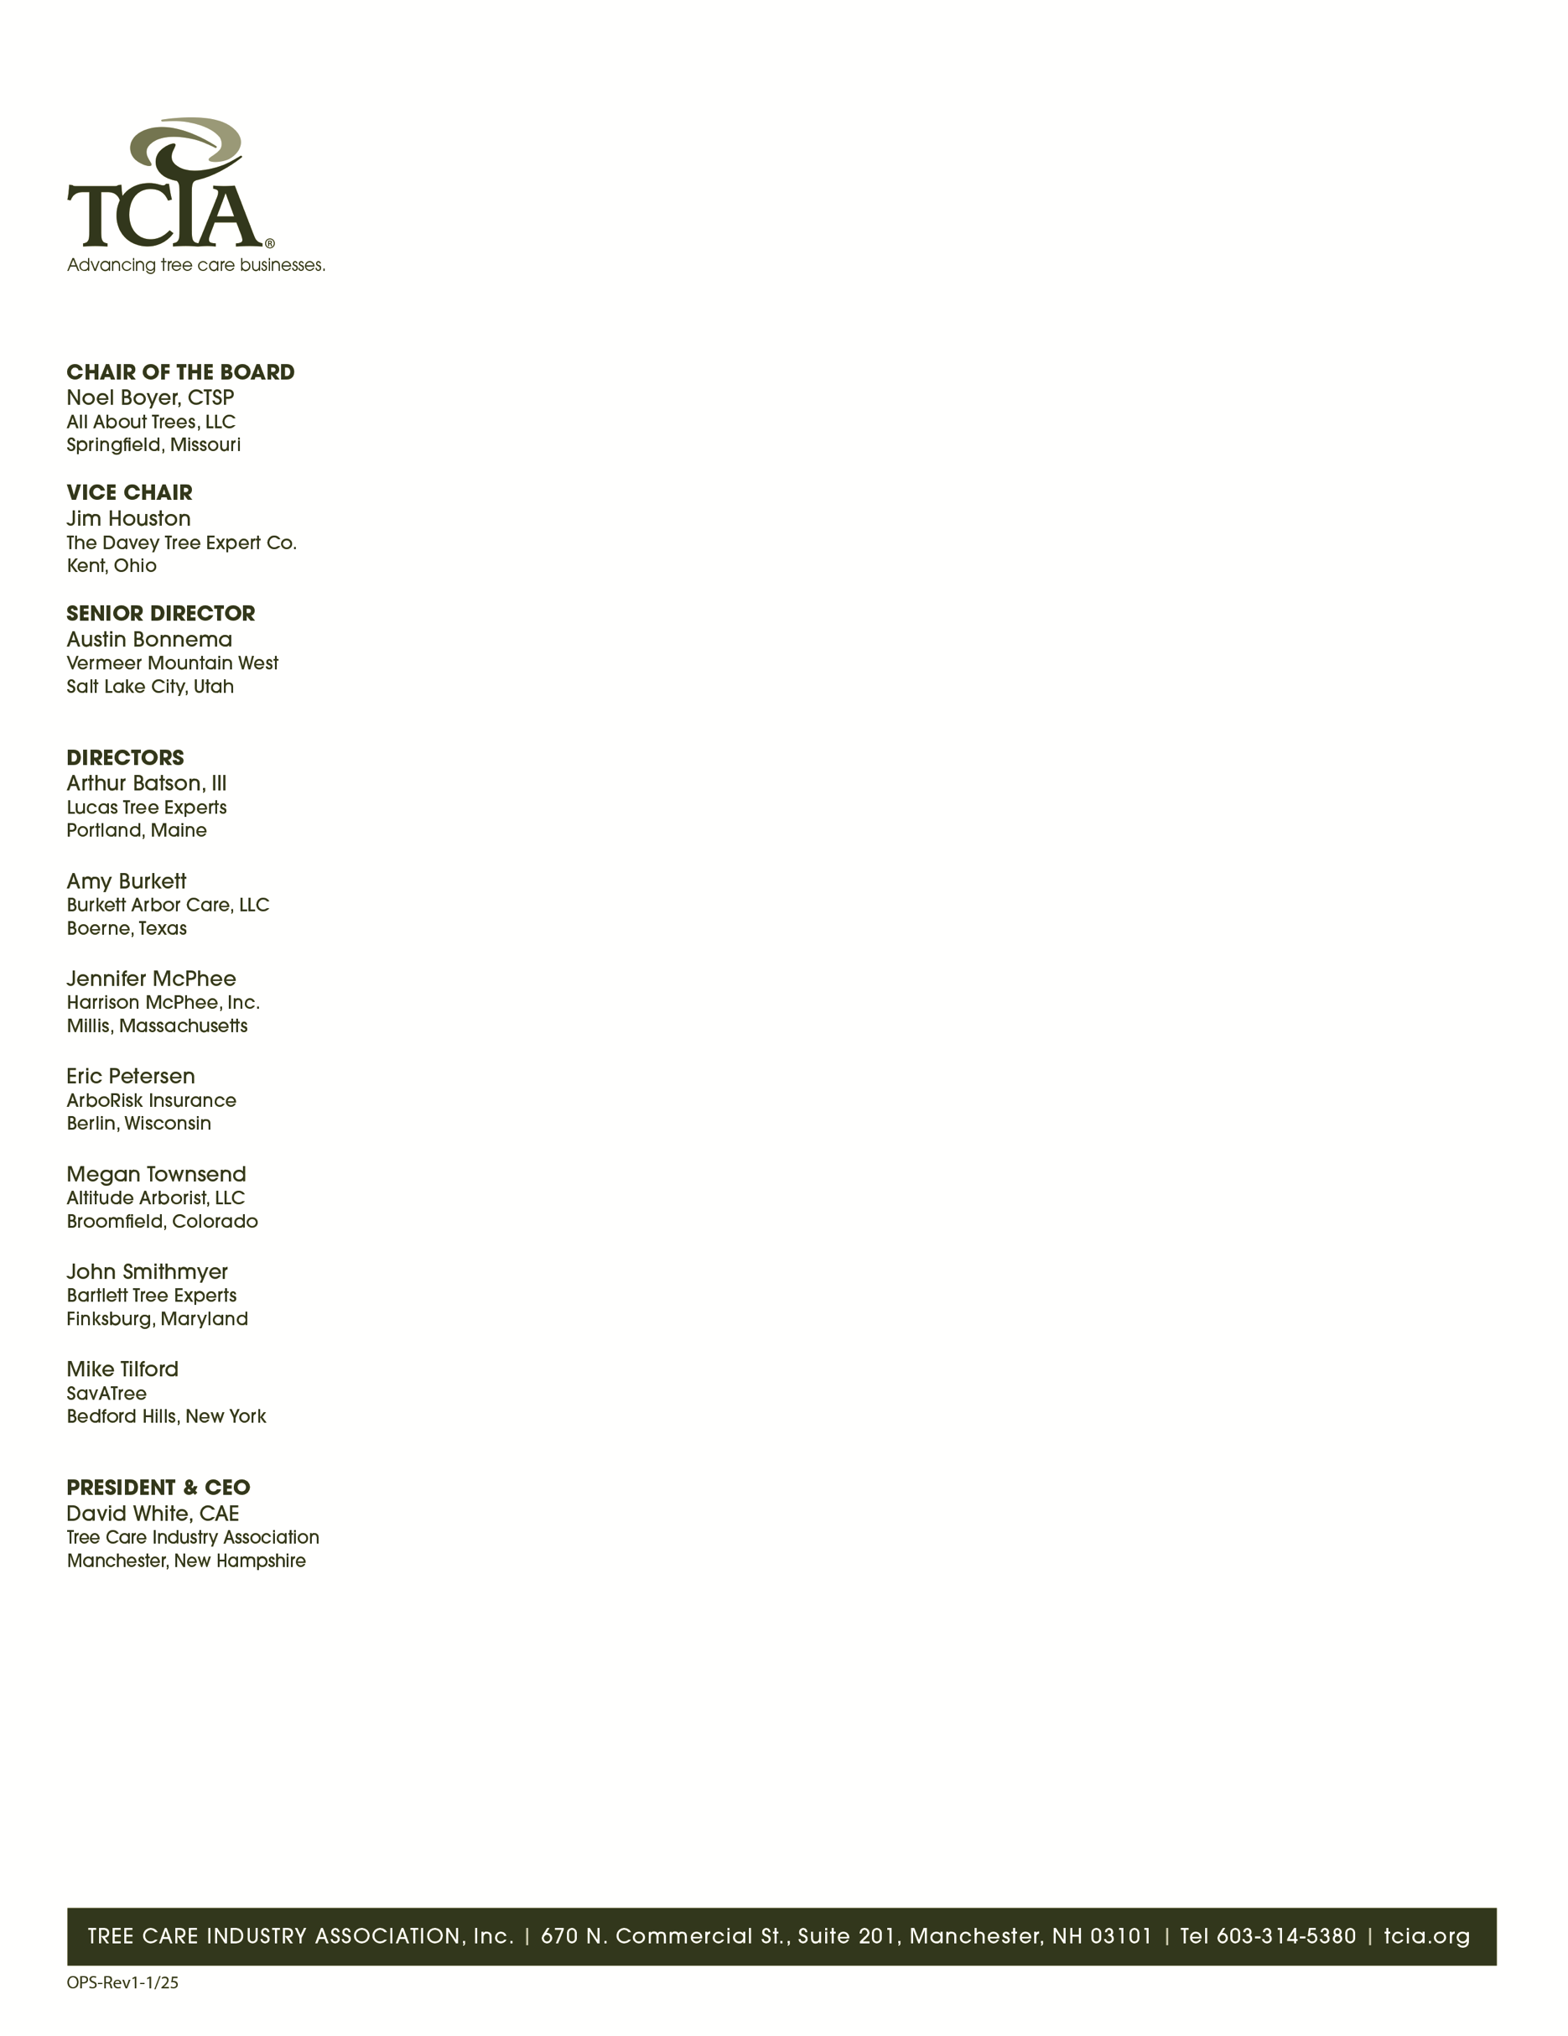
February 17, 2026

Nancy Stremple, Designated Federal Officer
USDA Forest Service
201 14th and Independence SW
Washington, DC 20250

RE: Letter of Support for JP McDonnell's Nomination to NUCFAC
Dear Ms. Stremple:
On behalf of the Tree Care Industry Association (TCIA), I strongly endorse JP McDonnell's nomination to serve on the National Urban and Community Forestry Advisory Council (NUCFAC) as the member representing a professional renewable natural resources or arboricultural society. Mr. McDonnell's active leadership across multiple professional organizations, combined with his technical expertise and deep understanding of industry consensus standards, uniquely position him to serve as an effective liaison between NUCFAC and the professional societies that support urban and community forestry nationwide.
Multi-Society Leadership and Liaison Capacity
Mr. McDonnell holds active leadership positions across the major professional organizations serving arboriculture and urban forestry. Within the International Society of Arboriculture (ISA), he serves on the Certification Test Committee and previously served on the Appeals Committee. Within the American Society of Consulting Arborists (ASCA), he serves as Chair of the Membership Committee and is an ASCA Academy graduate. Within TCIA, he serves on the Council of Tree and Landscape Appraisers Content Review Committee for the 11th Edition of the Guide for Plant Appraisal. Within the Urban and Community Forestry Society (UCFS), JP served on the Industry Trends Committee.
This engagement across ISA, ASCA, TCIA and UCFS is rare and positions Mr. McDonnell to serve as an effective liaison between NUCFAC and these organizations. He understands each society's mission, capabilities, and priorities. He has established relationships with leaders across all four organizations. He can efficiently communicate NUCFAC's needs to professional societies and articulate society perspectives to the Council, facilitating the coordination essential for implementing federal urban forestry initiatives through professional networks.
Subject Matter Expert for Industry Consensus Standards
Mr. McDonnell serves as SavATree's Voting Representative on the American National Standards Institute (ANSI) A300 Standards Committee where he contributes to developing the consensus-based performance standards that define professional tree care nationwide. These ANSI A300 standards which cover pruning, risk assessment, soil management, structural support systems, and other practices form the foundation for municipal tree care specifications nationwide.

Mr. McDonnell understands how consensus standards are developed, how they influence municipal programs and grant-funded projects, and how they can be leveraged to ensure quality outcomes in urban forestry initiatives. As NUCFAC develops criteria for the Forest Service's challenge cost-share grant program and evaluates the implementation of the National Urban and Community Forestry Action Plan, Mr. McDonnell can serve as a subject matter expert on how industry standards support program quality and accountability.
Strategic Value to NUCFAC
Professional societies serve as essential implementation partners for federal urban forestry programs. ISA, ASCA, TCIA and UCFS provide the credentialing, training, best practices development, and knowledge dissemination infrastructure that ensures quality professional practice nationwide. Mr. McDonnell's ability to serve as a liaison across these organizations will enable NUCFAC to more effectively leverage professional society resources in developing and implementing the National Urban and Community Forestry Action Plan.
His expertise in consensus standards development positions him to help NUCFAC establish criteria for grant programs that promote quality outcomes while maintaining flexibility for diverse community contexts. His experience managing budgets, overseeing projects, and balancing competing priorities demonstrates the practical judgment necessary for evaluating program implementation and making strategic recommendations.
I strongly recommend JP McDonnell's appointment to NUCFAC as the representative of professional renewable natural resources and arboricultural societies. His multi-society leadership, standards development expertise, technical excellence, and commitment to advancing urban and community forestry make him uniquely qualified to serve the Council with distinction. We are confident he will effectively represent the interests and perspectives of professional societies while contributing meaningfully to NUCFAC's critical mission.
Please contact me if you have any questions or require additional information.
Sincerely,
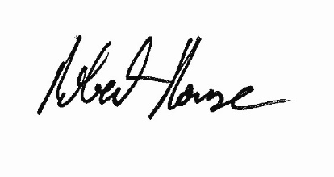
Bob Rouse
Senior Vice President, Industry Expertise / ANSI A300 Secretary
Tree Care Industry Association

