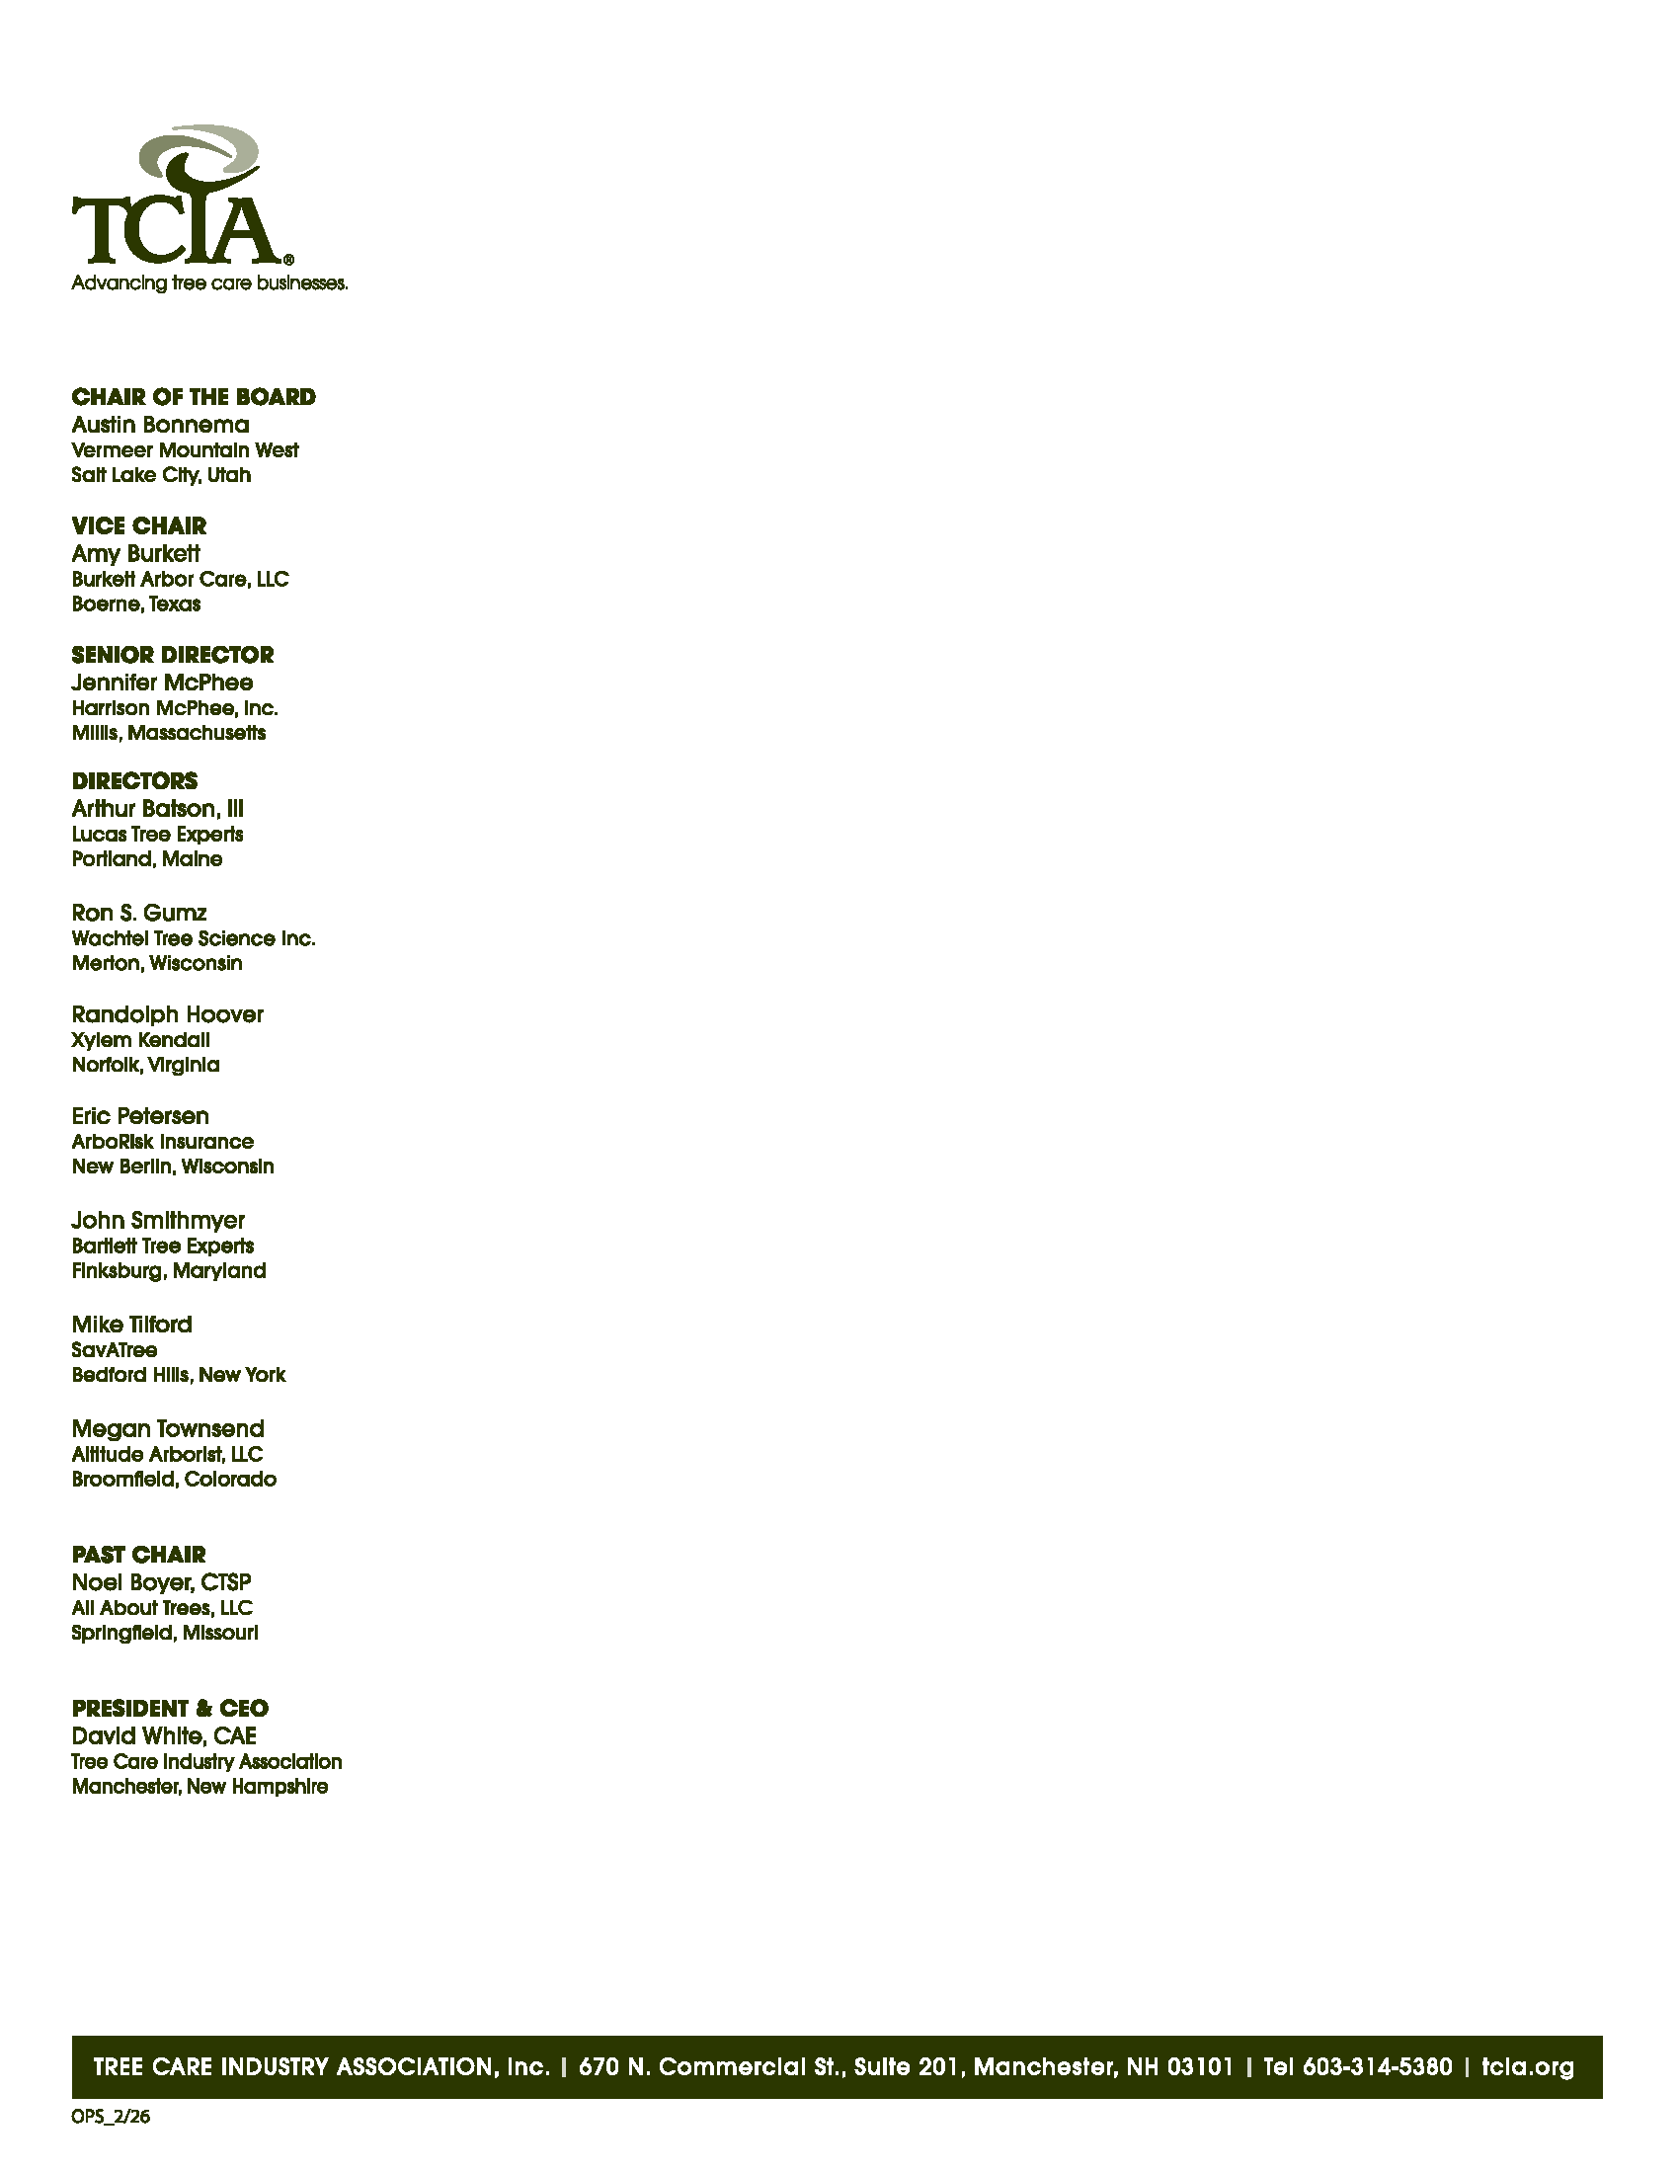
February 25, 2026

Chair Karla Lems
House Committee on Commerce and Energy
South Dakota State Capitol
500 East Capital Avenue
Pierre, South Dakota 57501

Subject: Senate Bill 36 – Clarification Regarding Vegetation Management Implementation

Dear Chair Lems, Vice Chair Bahmuller, and Members of the House Committee on Commerce and Energy:
On behalf of the Tree Care Industry Association (TCIA), I write to express our appreciation for the Legislature’s work to reduce wildfire risk through structured mitigation planning. Senate Bill 36 authorizes qualified utilities to establish wildfire mitigation plans and provides defined liability standards for utilities that maintain a valid and current plan and substantially comply with its essential elements. TCIA supports the goals of the bill and respectfully requests clarification that vegetation management work performed by specialized utility vegetation management (UVM) contractors—when conducted under the authority and direction of a qualified utility and in furtherance of a valid and current wildfire mitigation plan—is treated consistently with the liability structure established in Section 6.
TCIA is a national trade association representing approximately 1,400 businesses across the country that engage in commercial tree care, including utility vegetation management. Collectively, our members employ more than 150,000 people and provide critical services to residential communities, businesses, utilities, and governments. Our members play a vital role in wildfire prevention by identifying and mitigating hazardous vegetation near powerlines, maintaining utility rights-of-way, and reducing ignition risks in wildfire-prone areas.
In that context, section 4(3) of SB 36 requires wildfire mitigation plans to include the procedures, strategies, and standards a qualified utility will use to perform vegetation management. In practice, the majority of vegetation management required under utility wildfire mitigation plans—including inspection, hazard tree identification, right-of-way clearance, trimming, and removal—is performed by specialized UVM contractors operating under utility specifications and oversight. Utilities rely predominantly on contract personnel—not utility employees— to execute these field operations in accordance with the procedures, strategies, and standards set forth in the utility’s wildfire mitigation plan.
In turn, Section 6 conditions liability treatment on whether a qualified utility maintains a valid and current wildfire mitigation plan and has substantially complied with its essential elements. Vegetation management under Section 4(3) is one of those essential elements. As a practical matter, utilities demonstrate substantial compliance with vegetation management requirements through work performed in the field by qualified UVM contractors pursuant to the utility’s wildfire mitigation plan. The ability of utilities to meet the bill’s compliance standard is therefore closely tied to the continued capacity of specialized, insured contractors to execute plan-required vegetation management activities.
Because contractor capacity is tied to insurance availability, the wildfire insurance market for well-established utility vegetation management (UVM) companies is increasingly constrained. Legal uncertainty surrounding liability allocation in wildfire-related litigation has made wildfire-exposed UVM work difficult for insurers to price, resulting in materially higher premiums, reduced coverage limits, and, in some cases, withdrawal of capacity altogether. In certain markets, excess liability coverage has become prohibitively expensive, and contractors are frequently offered policies with wildfire exclusions or defense-inside-the-limits provisions that shift significant litigation costs to the insured. UVM contractors have, in some instances, reconsidered wildfire-exposed work due to insurance cost or availability constraints. Even where liability is not ultimately established, contractors may be drawn into wildfire litigation based solely on their presence on-site, creating substantial defense cost exposure. Without clearer statutory alignment regarding risk allocation for plan-required vegetation management, these market pressures could persist, creating uncertainty for qualified UVM firms responsible for executing Section 4(3).
For these reasons, clarifying that contractor-performed vegetation management, when conducted under the authority and direction of a qualified utility and in conformity with a valid and current wildfire mitigation plan, is treated consistently with Section 6 would provide greater predictability regarding risk allocation. That predictability supports insurer participation, contractor capacity, and the effective execution of valid and current wildfire mitigation plans, thereby reinforcing the bill’s objective of enabling utilities to demonstrate substantial compliance with essential mitigation elements while maintaining the accountability standards established in the legislation.
Thank you for your leadership on this important issue. TCIA stands ready to serve as a resource as SB 36 moves forward

Sincerely,
David White, CAE
President & CEO, TCIA

